PF Assignment

Q1)

C = ear of Corn

Cs =smallest ear of Corn

Ct= total ears of corn

Cm = ear of corn in mouth

Cm 🡨 Cs

Ct = Ct -1

While Ct != 0

Start searching

IF C > Cm

THEN Cm 🡨 C

Ct = Ct -1

ELSE

Keep searching

END WHILE

Leave meadow

Q2)

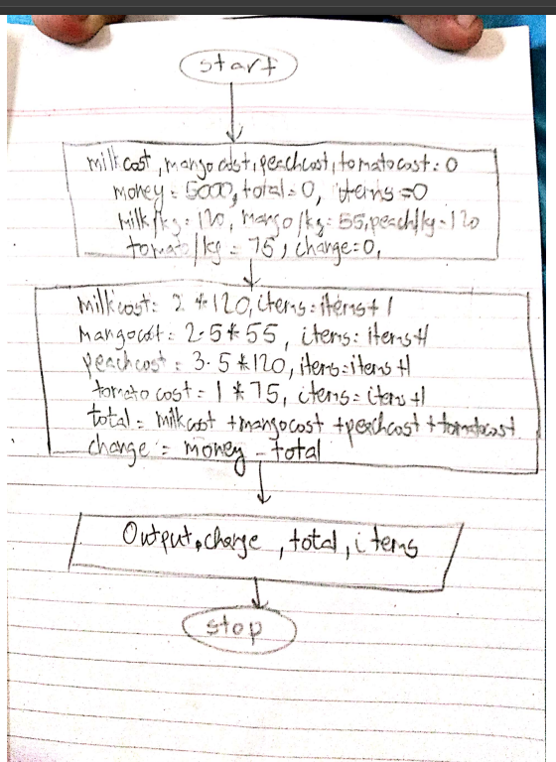

Q3)

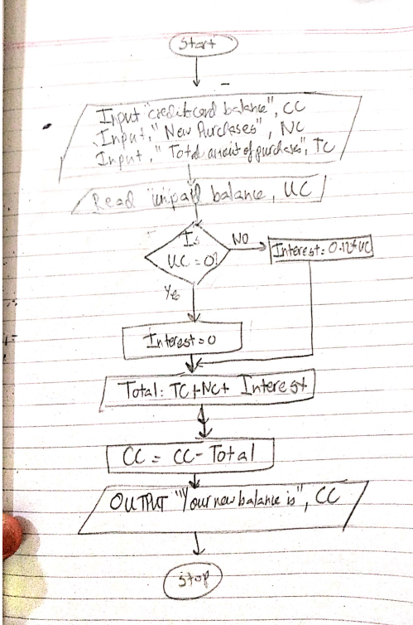

Q4)

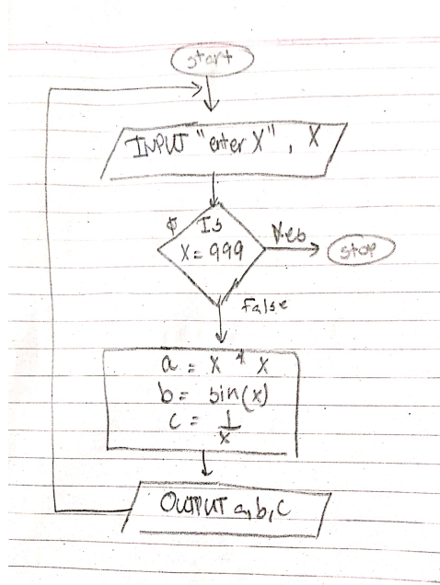

Q5)

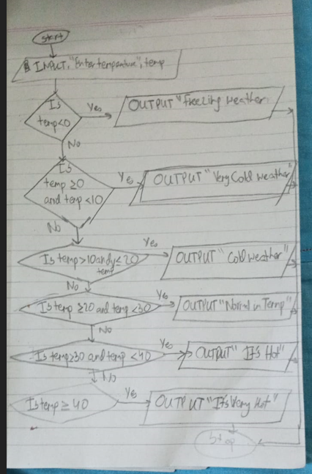

Q6)

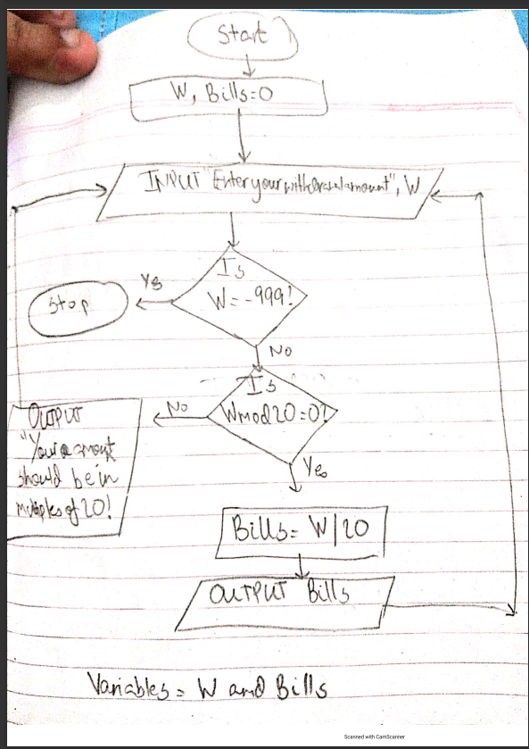

PAC:

|  |  |  |
| --- | --- | --- |
| **DATA** | **PROCESSING** | **OUTPUT** |
| “Withdrawal amount”, W | Wmod20 | Withdrawal amount the customer asked for in 20 dollar bills |
| “Amount of 20 dollar bills to be output”, Bills | Bills = W/20 |

IPO:

|  |  |  |  |
| --- | --- | --- | --- |
| **INPUT** | **PROCESSING** | **MODULES** | **OUTPUT** |
| “Withdrawal amount”, W | Output withdrawal amount in 20 dollar bills | 0.0 | Withdrawal amount the customer asked for in 20 dollar bills, Bills |
| “Amount of 20 dollar bills to be output”, Bills | INPUT W and initialize Bills | 1.0 |
|  | INPUT “withdrawal amount” W | 1.1 |
|  | Bills = 0 | 1.2 |
|  | Check if W is divisible by 20 and calculates number of dollar bills | 2.0 |
|  | Wmod20 = 0 | 2.1 |
|  | Asking for input again if withdrawal amount is not in multiples of 20,  Wmod20 != 0 | 2.2 |
|  | Bills = W/20 | 2.3 |
|  | OUTPUT “The number of 20$ bills you will receive are”, Bills | 3.0 |

Q7)

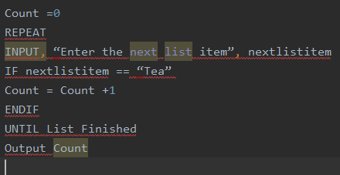

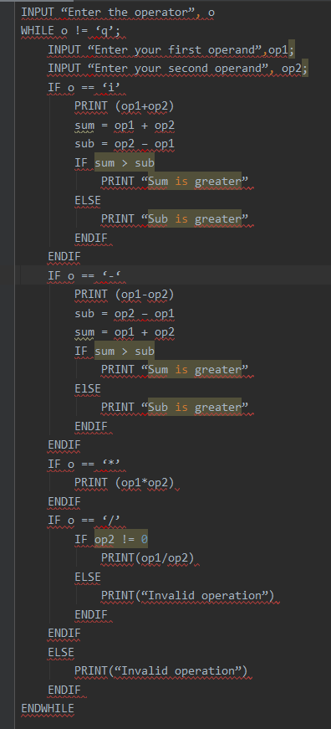 Q8)